**Homework 2 – Ben Joye**

**CPSC 2150**

**Requirements Analysis:**

* **Functional**
  + As a user, I can input what column to place my piece into so that it is stored in the board array
  + As a user, I can see the board array after every turn.
  + As a user, both players will alternate turns.
  + As a user, I can choose to play again so that the game will keep running.
  + As a user, I can input numbers to decide the size of the game board.
  + As a user, I can input numbers to decide the number of pieces in a row you need to win.
* **Non-Functional**
  + The system must be able to detect when a player has won.
  + The system must display which players turn it is.
  + The system must keep track of every move and display the board after every turn.
  + The system must handle a board size of up to 100 rows and 100 columns.
  + The system only lets dimensions from 3 to 100 for the board array.

**Design:**

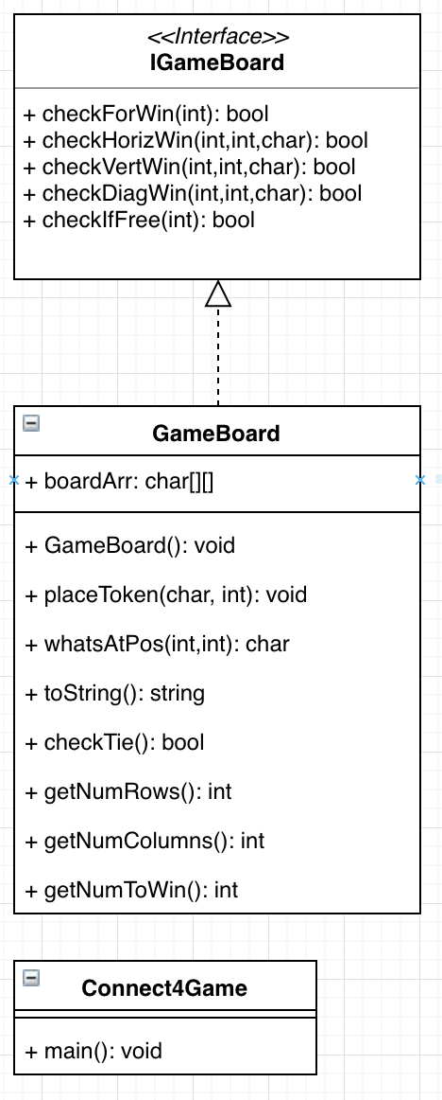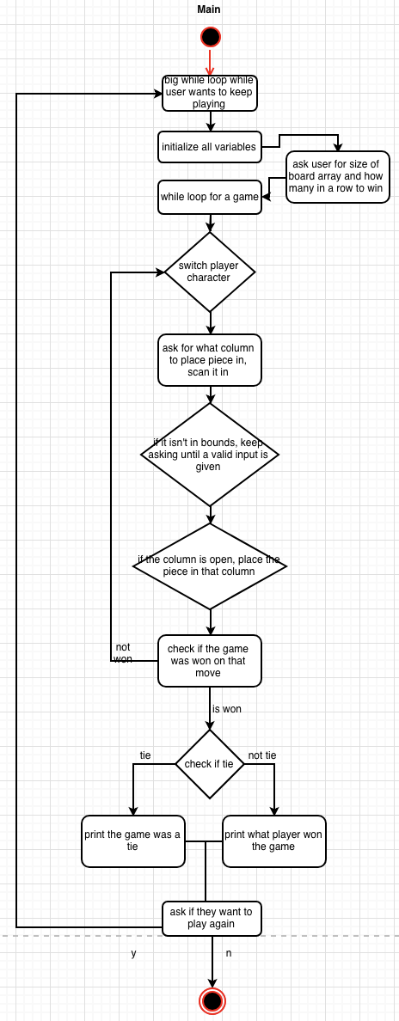

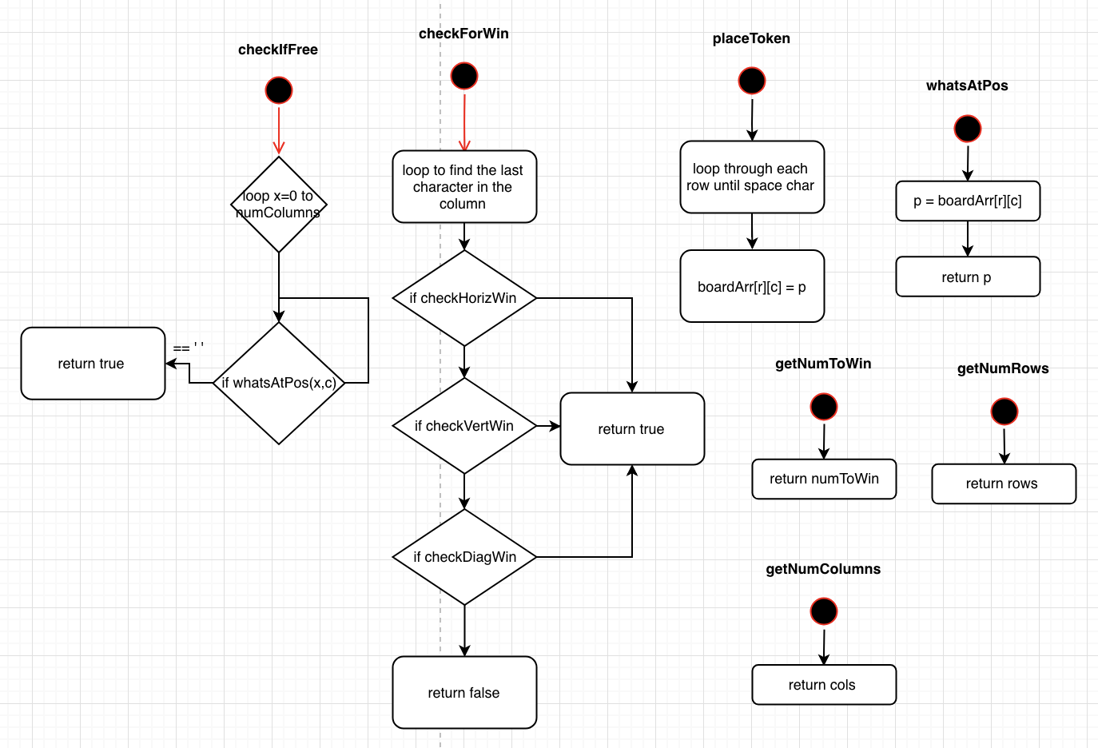

**Testing:**

* I tested winning with horizontal, vertical, and diagonal rows.
* I tested to make sure all the columns can be filled up.
* I tested only valid inputs can be put in.
* I can type y to play again after a round.
* I can type n after a round to end the game.
* If I input invalid board sizes, it asks again.
* If I input invalid in a row to win, it asks again.

**Deployment:**

* Type make to compile the program
* Type make run to run the program